Practical No.2
NAME - NASRULLAH \ ROLL NO - 44
Aim: To study types of variables and methods, passing class members, Inheritance , and constructors in inheritance.
1. Types of variables in python OOP:
Static variable, Instance variable, and Local variable
Input:
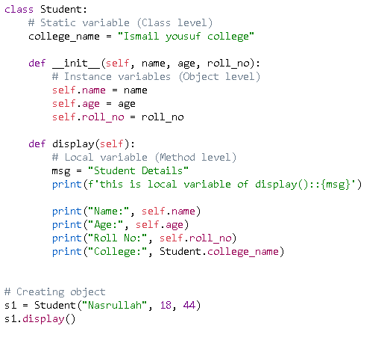
OUTPUT:-
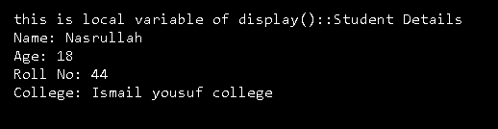
2. Types of Methods in python OOP:
A) Instance Method
Input:
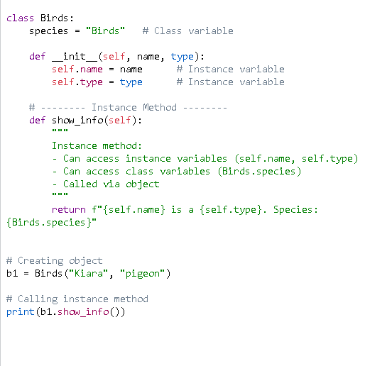

Output:
B) Class Method
Input:
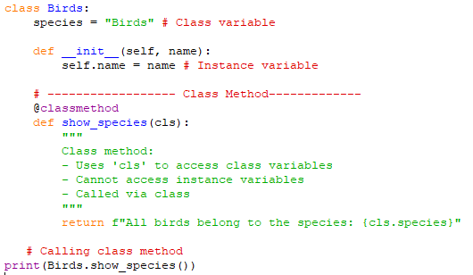

Output:
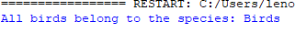

C) Static Method

Input:
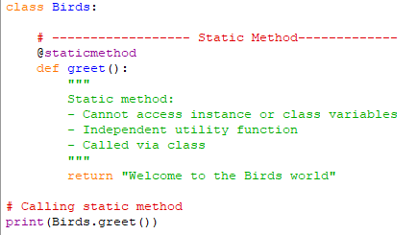

Output:
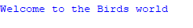

3. Passing class members between classes
Input:
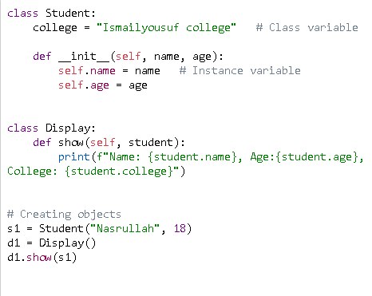

Output:
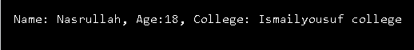

4. Inheritance:
Single Inheritance:
Input:
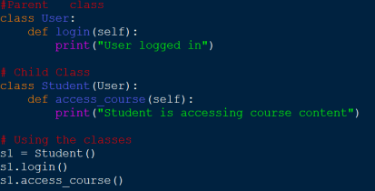
Output:
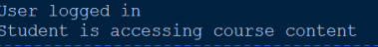

Multiple inheritance:
Input :
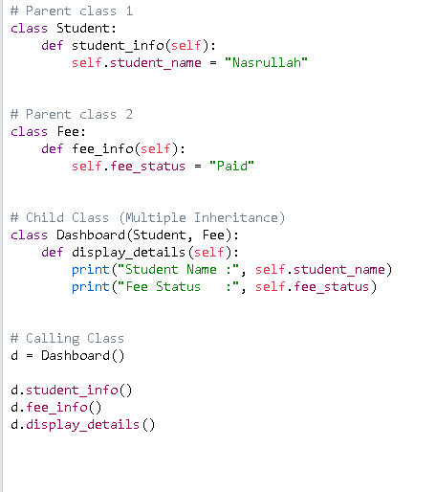

OUTPUT:
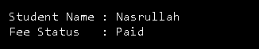

Multilevel inheritance:
INPUT:-
: 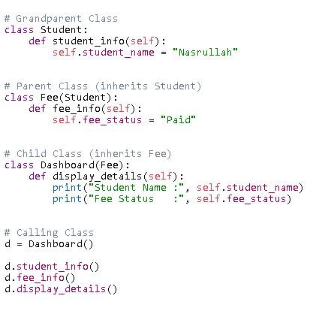
Output:


